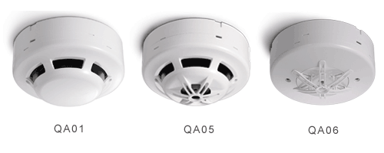
QA01 Addressable Photoelectric Smoke Detector
QA05 Addressable Combination Smoke & Heat Detector
QA06 Addressable Heat Detector
Characteristics
- Latching function helps to identify alarm device clearly and quickly.
- Address coding by dip switch makes the job easier.
- Magnetic test feature makes maintenace easy and simple.
- Non-loosening screws on base terminal for easy installation.
- Detector is made of high endurance, solid and colorfast Fire-proof plastic.
- Detector has passed strict EMC test, which greatly eliminates fasle alarms caused by interference from nearby sources.
- Dual LEDs for 360-degree visibility.
Specifications

Model | QA01 | QA05 | QA06
Address Coding | Binary
Alarm Current | DC24V 6mA
Standby Current | DC24V 850uA
Sensitivity Setting | Comply to EN54
Ambient Temperature | 0ºC ~ +50ºC
Thermal Setting | N/A | 58ºC | 58ºC
Dimensions (mm) | 102(Dia.)x48(H) | 102(Dia.)x54(H) | 102(Dia.)x46(H)
Weight | 130g | 130g | 115g
Material | Fire-proof plastic
Color | White

